AIM: To implement a Neural Network classification model using Python to predict students' results (Pass or Fail) based on hours studied, attendance, and assignments using the data.csv dataset.
ALGORITHM:
1. Start the program.
2.Import Pandas, TensorFlow, and the required Scikit-learn libraries.
3. Load the dataset from data.csv.
4. Remove extra spaces from the column names.
5. Select Hours studied, Attendance, and Assignment as input features.
6. Select Result as the target variable.
7. Convert the categorical labels Pass and Fail into numerical values (1 and 0).
8. Split the dataset into training and testing sets using an 80:20 ratio.
9. Apply feature scaling using StandardScaler.
10. Build a Neural Network with two hidden layers containing 8 and 4 neurons, respectively, using the ReLU activation function.
11.Add an output layer with one neuron and a sigmoid activation function.
12.Compile the model using the Adam optimizer, binary cross-entropy loss, and accuracy metric.
13.Train the model for 50 epochs.
14.Predict the results for the test dataset.
15.Convert the predicted probabilities into class labels using a threshold of 0.5.
16.Calculate and display the accuracy score.
17.Stop the program

OUTPUT:
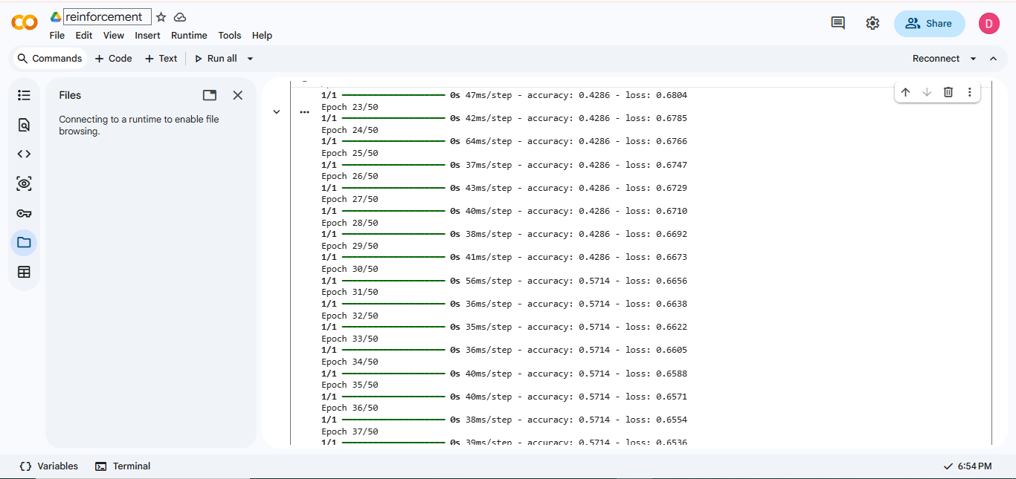

RESULT: Thus, the Neural Network classification model is implemented successfully to predict students' results and evaluate the model accuracy.

